Report Advanced PL/SQL

by Aliaksandr Labayeu

# 1. Schema of CE layer is:

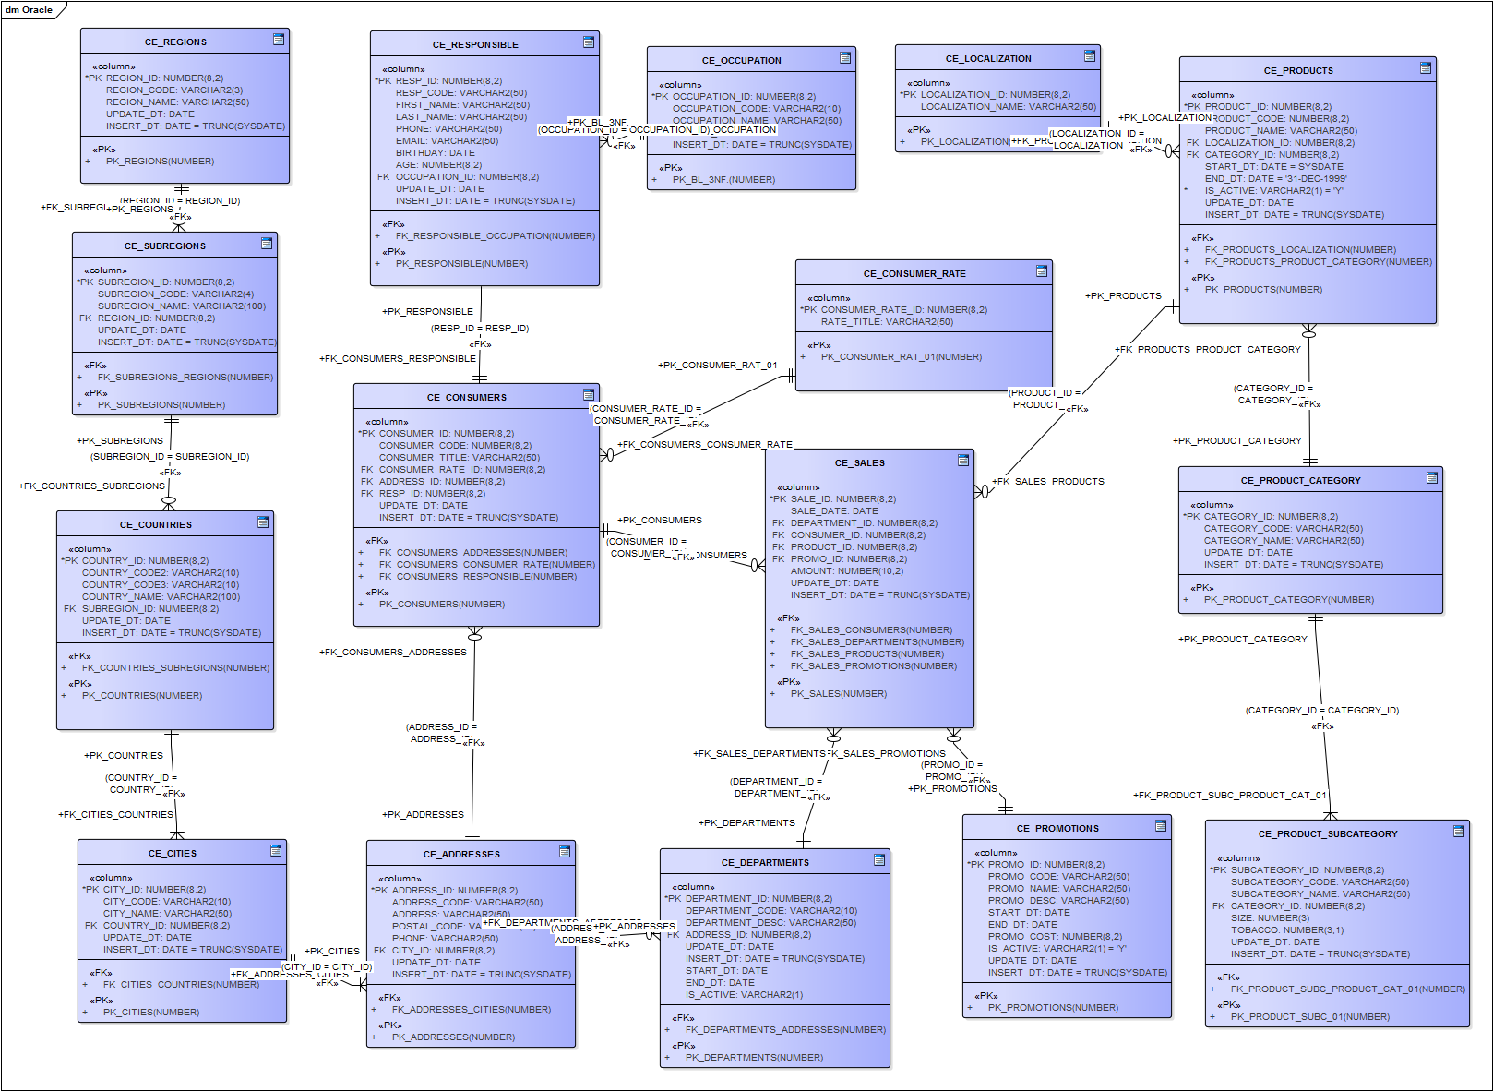

CE_SALES – fact table ON DWH layer

# 2. Contributing data from CLS -> CE

Prepared PROCEDURES (for each table on CE layer) in one package “CE_DDL_Body”

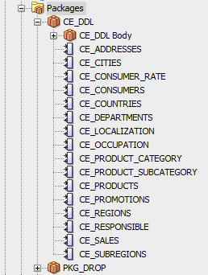

The result of the execution is tables with data and future fact table SALES:

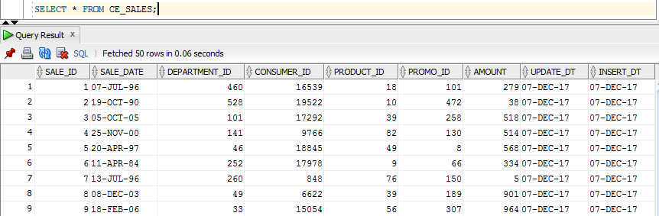

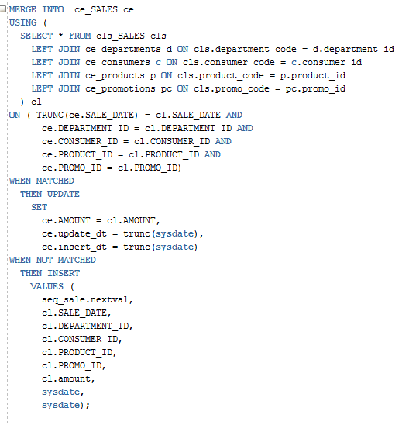

Merging

|Due to the usage of MERGE statement we do not insert rows which are already in table

